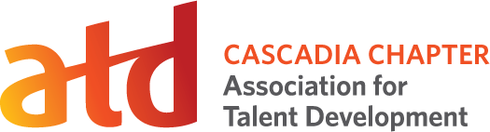Annual Member Meeting
Meeting Minutes
November 18, 2019
Date/Time | November 18, 2019
Location | Bad Habit Room, Portland, Oregon
Board Attending | Erin Bair, President  Diane Gilmore, Past President  Steve Brooks, Director, Membership  Kerri Nussbaum, Director, Volunteers
Board Not Attending | D.J. Netz, Secretary/Treasurer  Kathleen Bergquist, Executive Director
Members Attending | Maggie Ballard, Kameron Giacchero, Jared Gracie, Pamela Moore, Marla Turner, Dan Vetter
Non-Members Attending | Dana Canaday, Danielle Conroy, Brian Darby, Michael Pahle, Marissa Parker

The meeting commenced at 6pm.

Update
Erin gave an overview of the chapter’s financial picture. A balance sheet was made available for anyone interested in seeing it and a short presentation was provided outlining major points, including:

- We are on track to meet our financial obligations for 2019. We have a modest amount of savings for4 contingency.
- Meanwhile we are working to populate our Events page with a terrific series of workshops for the first half of 2020.
- We had a very successful conference. We continued to keep expenses lean. We are happy to announce that we will present a conference again in 2020.
- Membership revenue dropped slightly in 2019. Our board will renew our efforts for member outreach in 2020.
- Fundamentals of Training has been a huge success, exceeding projections by 33%.

The meeting adjourned at 8pm.

